**CHATZGOLF NEWSLETTER**

**Edition: 2025 – 1st Quarter**

**The main point of interest this term for Chatz members has been the successful introduction of Golfify. Following extensive trials and a fair bit of troubleshooting, we are now employing the Golfify app to score our games. This has proved a real boon for after game scrutineering and enabled more timely results presentations. And a real side benefit is the live monitoring of other games and individuals progress via the ‘leaderboard’ facility. Golfify comes at a reasonable annual cost to the club and is proving to be a worthwhile investment. Thanks so much to Robyn van Yzendoorn for being the driving force and chief researcher into this facility. Robyn remains the ‘host’ for each week’s games and it is she who sets it up for our benefit each Sunday – even when she is not playing herself.**

**Whilst Golfify has the facility for members to register their intention to play each game, your secretary still requires replies to the call for players as this remains the only way to know who wants a cart (and is perhaps a simpler way to cater for the inevitable withdrawals and changes of mind!). And down the track, we’ll also have you to update your handicaps yourselves.**

**Another matter affecting Chatz members concerns carts at GGC. Over recent years we have maintained a regular booking of 5 carts and frequently have had to cancel 1 or even 2 of those come Sunday morning (or actually, on Friday afternoon). However, this year, with the further increase to our numbers (and perhaps the aging demographic), we are noting demand for 6 and once even 7 carts at GGC. Extra carts are not usually available at short notice and this has forced us into prioritizing and asking members could they walk to accommodate those who cannot. Thankfully, and generously, mostly this has been acceded to. A request has been made to the pro shop and it looks like we will be able to have 6 carts for the rest of this year (except in November). Hopefully, this will satisfy the increasing demand.**

**It is most pleasing to note that first term game attendance has been excellent. The 6 games at GGC have averaged over 20 per game (the wet weather, especially on 30th Mar hurt) and we saw 20 members play at beautiful Blackheath, the best attendance at this venue for some years. These numbers have been aided by another 3 new members: James Reilly and Tom Richardson joined us in January and Robert Iligan signed up in February. James & Tom have both secured Chaz handicaps (25 & 28 respectively) whilst Robert has submitted his first card.**

**CHATZ SOCIAL GOLF CLUB INCORPORATED**

 *Affiliated sporting club of Chatswood RSL Club*

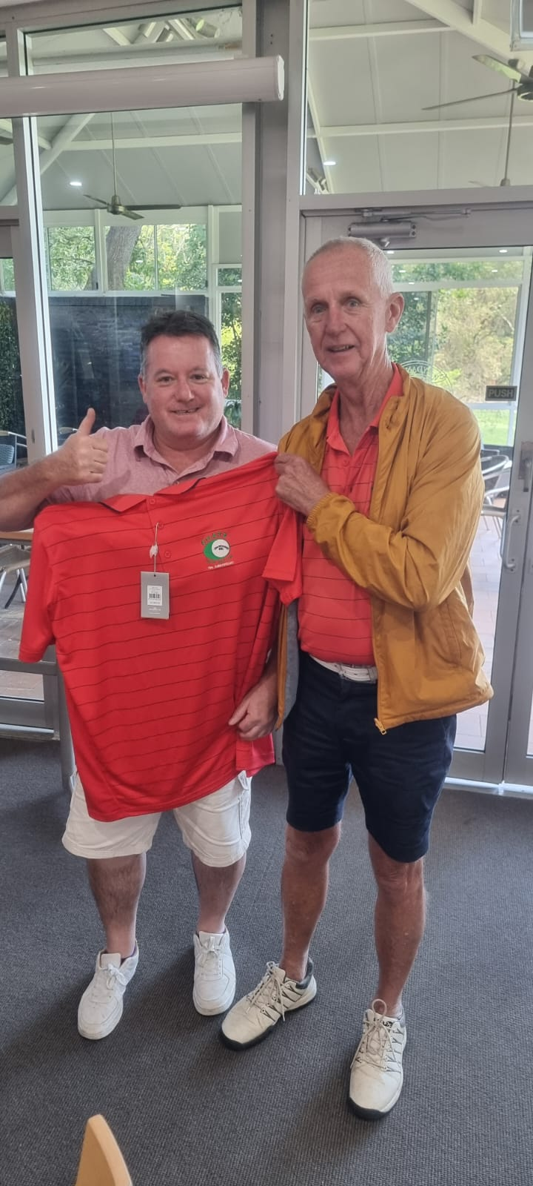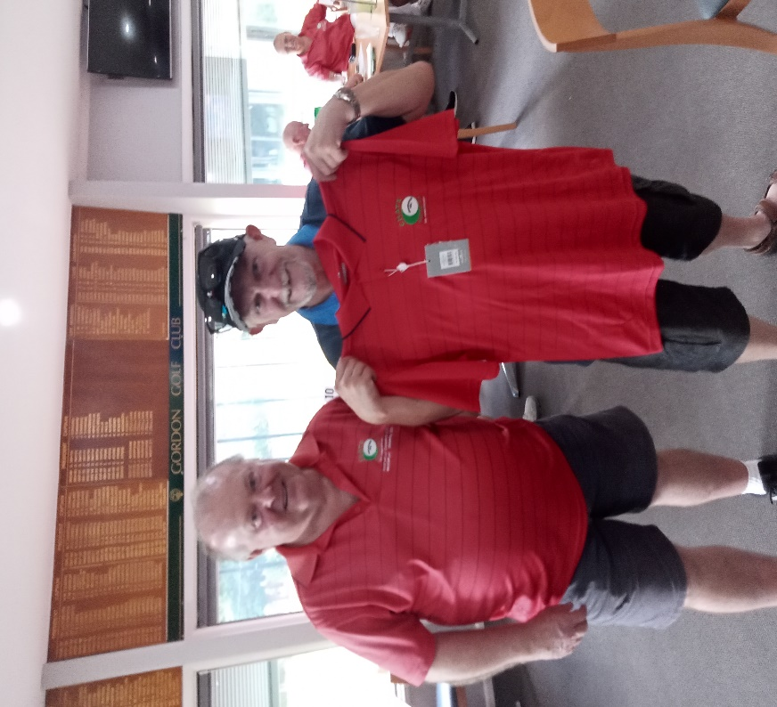

**With our (almost) weekly results, two of our ‘newbies’ have featured this quarter. Scoring their maiden Chatz victories were Andrew Fraser at Blackheath (2nd Mar) and Tom Richardson at GGC (9th Mar). Coincidentally, both won with 3 under handicap tallies.**

**Meanwhile, not on another planet, the temperatures march onwards and upwards. The World Met. Organisation confirmed 2024 was the hottest on record. The oceans were the warmest ever in 2024 with a rate of warming twice that of 20 years ago. World-wide, there were more than 150 ‘unprecedented’ extreme weather events. The Sydney 24/25 Summer was our hottest on record with NSW recording its second hottest Summer with temps 1.8C above average. Sydney set new records in March. Australia as a whole saw temps rise 1.89 above the annual average.**

The green is down there Jack!

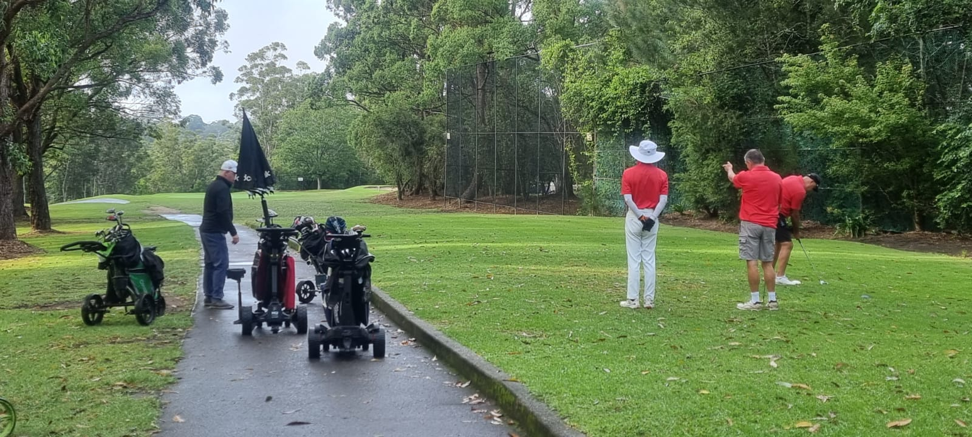**Why so hot? Several factors: the Northern monsoon was late, the prevailing Southern latitude Westerlies were further North than usual (meaning lower than usual rainfall), the surrounding sea temps were well up and, of course, the underlying warming of the planet all played a part. It will be difficult to reach the Paris Accord targets by 2030 and 2050! But no worries, we can still “drill baby drill”.**

**CHATZ SOCIAL GOLF CLUB INCORPORATED**

*Affiliated sporting club of Chatswood RSL Club*

**COMPETITIONS**

**Matchplay**

**Our Matchplay comp commenced on 16th Feb following the qualifier a week earlier. The initial draw had to be re-jigged following the late withdrawal of one of our higher qualifiers. The first round saw some good scores highlighted by Danny O’Brien’s eagle on the 13th which certainly aided his first up win. The quarter final second round saw Steve Hipsley, Neil Vidler, Col Loughlin & Patrick Chye progress to the semi finals. These two games resulted in Neil and Col meeting in the final after close 3&2 and 3&1 wins. (Special mention here of Patrick’s effort: Patrick was 6 down after 6 holes, but fought back courageously to take it right through to the 17th!)**

 

**In the final, conditions were not great with rain falling and very soggy conditions underfoot. And the back 9 greens had been sanded recently making for even more difficult conditions. But Col signalled his intent straight away with a booming drive on the first which led to a first up win. However, the game continued to be close until the turn with Col & Neil taking 3 holes each to be all square standing on the 10th tee. But Col faded somewhat on the back 9 (was it the late night?) and, coupled with a great 37 off the stick, Neil won through with a 4&3 victory.**

**In the Plate final, we saw a keen battle between Terence Cheong & Steven Tan. Terence led by 1 at the turn but Steven used his higher handicap to advantage on the back nine to pull ahead, winning 4 of 7 holes and a squared 17th saw him a 2 up winner.**

**CHATZ SOCIAL GOLF CLUB INCORPORATED**

*Affiliated sporting club of Chatswood*

**Pointscore**

**It is early days yet but the first quarter has produced 2 clear Pointscore leaders. Neil Vidler used his good Matchplay form to score 2 wins on the trot and take the lead with 33 points. Close behind is Laurie Benkovich with 31, courtesy of two seconds & two third placings. There’s a bit of a gap then back to Jack Saliba on 21 with Steve Hipsley pushing on 20. Nineteen is a popular score at the moment with no less than 5 members there (Elly, Dave Bezer, Kathy, Tom Richardson & Danny O). At this early stage, Steve & Neil are the only two players to have recorded two wins.**

**Eclectic**

**We also have a clear leader in the Eclectic comp. Already ahead by 2.5 strokes is XP Guo with 47.5, which score features 5 birdies for a nett 4 under. It’s an impressive first quarter score but can he improve further on an already great score and remain ahead of the chasing pack for 9 more months? Not too far back is Patrick Chye with a very handy 50 points and an advantageous handicap. Further back it gets a little more bunched where we see Steve Hipsley on 53 with Kathy Fraser, Col Loughlin & Dave Martin all on 53.5.**

**CHATZ CHATTER**

**The North Turramurra GC major pennants team, with William Soo captaining, had an outstanding year in the division 4 competition. The team won division 5 last year to be promoted and this year made it right through to the division 4 final where they played Antil Park GC. Unfortunately, success eluded them in the final but making the final meant further promotion to division 3 for next year. Congratulations to William and your team.**

**A couple of our members had hospital stays early this quarter but we are pleased to note that both Captain Dave Bezer & Terence Cheong have both made good recoveries and welcome returns to the game. And from their scores, it seems that the golf hasn’t suffered.**

**CHATZ SOCIAL GOLF CLUB INCORPORATED**

*Affiliated sporting club of Chatswood R*

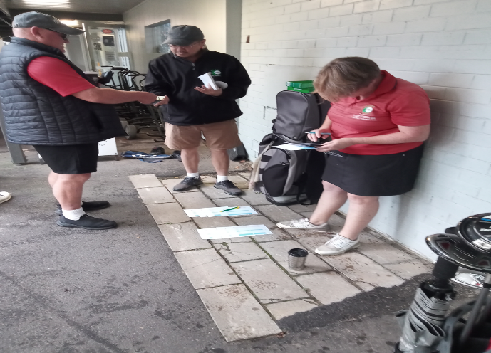 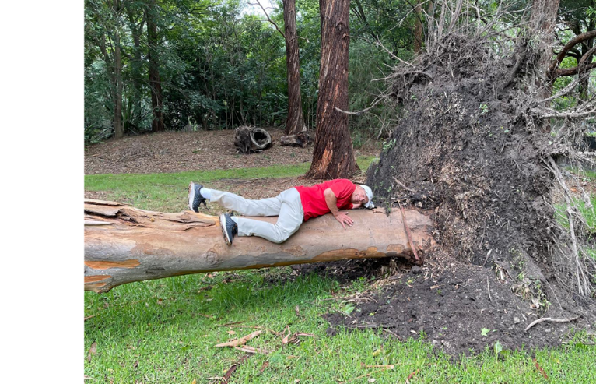

**And a great day and attendance at Leura to open our away game year:**

** **

** **

**CHATZ SOCIAL GOLF CLUB INCORPORATED**

*Affiliated sporting club of Cha*

**WEDNESDAY WARRIORS**

**Our Wednesday Warriors were worried wecently with worsening wet weather while wondering whether to wander course-wards or wait with wesignation, which woefully was warranted some weeks. ☹**

**In fact, the diehards have had a bad run missing several Wednesdays due to bad or threatening weather and coring & sanding works on the greens & tees. In the end, we missed about 4 or 5 weeks this term severely limiting our practice sessions for the Matchplay championships on Sundays. Nonetheless, some good play was managed with start times creeping later as the beautiful sunrises got later.**

**Maybe it’s been said before but dawn is a beautiful time to play & commune a little with nature. If interested, we usually have a playing spot available and it’s only $29, less if you are a GGC member!**



KC plays ‘Misty for Me’ GGC 11th Tee Wed 26Mar

*Opinions expressed in this newsletter are those of the Editor and not necessarily those of the Chatz Social Golf Club*

**---------------------------------------------------------------------------------------------------------------------------------------**

**CHATZ SOCIAL GOLF CLUB INCORPORATED**

*Affiliated sporting club of Chatswood RSL Club*

**­­­­­­­­­­­­**