**CHATZGOLF NEWSLETTER**

**Edition: 2025 – 2nd Quarter**

**What can we say about the weather? Its just been awful! Following earlier major inundation in Qld, the mid-North coast of NSW got smashed in May with major flooding everywhere with the Taree area particularly hard hit. Sydney escaped the worst of it but the edge of the weather pattern did affect us locally with rain being recorded pretty well every day through April & May and into early June. And, as we go to press, a nasty East coast low is developing off the coast of Sydney with nasty weather looming for the first 2-3 days of July. Fingers crossed it’s not too bad!**

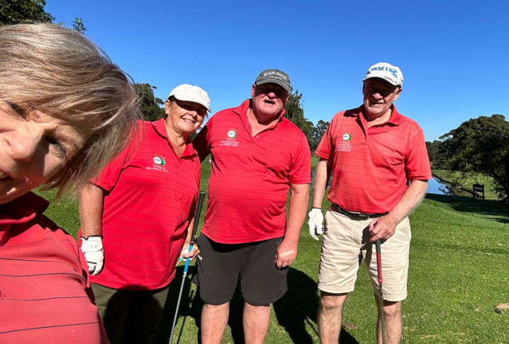**A lowish turn out in Springwood saw fine weather but the Mittagong game, whilst starting well, didn’t finish quite so with the last 3 or 4 holes being played in drenching rain, a disappointing end for the 13 members who braved the dire forecast and almost made it through unscathed. A similar forecast didn’t bode well for Massey Park a week later. This time 14 members risked it and actually found the walking acceptable albeit with some pretty soggy areas (and a very full canal!). And then came GGC on 18th May. There was no mystery about the forecast and actual weather on the day. With no carts, showers and very threatening clouds, just 8 (fool?) hardy souls set off for Monty’s magical mystery tour. Between then and 1st June, we didn’t have a game and just as well. Plenty of the wet stuff saw some courses wholly or partly closed or, at least, no carts allowed. We walked Asquith in fair conditions with a 6°C start but a beautiful sunny 15°C finish and enjoyed the outing despite the very wet conditions underfoot.**

**Despite all the rain, Sydney recorded its second warmest Autumn ever with May the hottest month. The seas are running 1-2°C above average and that explains the very high airborne moisture content and the heavy and consistent rainfalls. The 1-in-100 year floods are occurring much more frequently.**

**CHATZ SOCIAL GOLF CLUB INCORPORATED**

 *Affiliated sporting club of Chatswood RSL Club*

**COMPETITIONS**

**Patron’s Trophy**

**Perhaps celebrating the return of some good weather, we saw one of our better turn-outs for this year’s PT event with 12 pairs teeing off on a bright crisp Sunday morning. Individual scoring in rd1 was average (with no one bettering handicap) but some pairings put it together well despite the occasional soggy areas and slowish greens. Col Loughlin & Neil Vidler were the early leaders combining well for 67 points to shade Terence Cheong & Kathy Fraser on 64 with Laurie Benkovich & Bruno Dalla-Palma 1 shot further back.**

**Round 2 was played in even better conditions as the course dried out and a wintery sun with a cool 6°C met the keen participants. The first round saw no one better handicap but round 2 featured 2 superb rounds from Patrick Chye (44 individual points!) and Col Loughlin (41). Broad-shouldered Col was given a little support by Neil and the pair held on to their first round lead to score 138 aggregate to win by 3 points from Patrick & Steve Grace who, thanks to Patrick’s strong round, improved from 4th place. First round 2nd placers TC & Kathy slipped a little to fifth (121) allowing Laurie & Bruno through to 3rd (129) while Dave Bezer & XP Guo improved from an equal 5th pack to finish 4th (125).**

**Well done Col & Neil, Patron’s Trophy champs for 2025.**

**Pointscore**

**Term 1 saw Neil Vidler (33) leading narrowly from Laurie**

**Benkovich (31) with the next best on 21 pts. Things have really**

**changed through term 2. We now see that Laurie has been very consistent to take over the lead on 53 points. Neil has almost kept pace albeit slipping to second on 49 whilst Terence Cheong has moved up to a close third on 47 points. Patrick Chye is close with 44 & Jack Saliba has 41. It’s unusual to see that, whilst leading, Laurie has yet to win a game this year but he has scored 3 seconds, 3 thirds and a bunch of minor placings – that’s good consistency. Patrick has been the big mover with 3 wins this quarter to go with 3 earlier second places.**

**CHATZ SOCIAL GOLF INCORPORATED** *Affiliated sporting club of Chatswood RSL Club*

**Eclectic**

**XP Guo has maintained his ascendancy in this comp throughout the term and continues**

**to lead despite not improving his score of 47.5. And XP is currently the only member under nett par with 61. (Danny O’Brien is next best here with an even 65.) The quarter’s big mover, in more ways than one, is Col Loughlin. Col’s great score in the PT event saw his nett score change dramatically but of course it cost him with a handicap change. His 51.0 is a good second but he still has work to do.**

**Dave Bezer also has mounted a challenge now with 51.25 and is well positioned for a 3rd term challenge. Pat Chye made a significant dent in XP’s lead until his 44 points cost him big in the handicap department but he still sits fourth with Kathy Fraser on 51.75. Also, not too far off the pace are Laurie Benkovich, Mike Brodie, Terence Cheong & Steve Hipsley, all on 52.25.**

**CHATZ CHATTER**

**Members might be pleased to know that we have been successful in securing a booking at Moore Park in April next year. This is a notoriously difficult course to make large social bookings at and, with major course reductions hanging over their head, this could be your last chance to play at one of Sydney’s iconic golf courses. It’s reputed to be Australia’s busiest public course. There will be some restrictions & conditions on playing: It’s a 24 player limited booking and players will need to nominate and pay for the round at least 7 days prior with no refund if you have to withdraw. It’s not cheap ($69) but it should be well worthwhile. More details closer to the event.**

**Following the success of last year’s mystery venue, we will also be returning to Beverley Park next year. And there is another mystery venue lined up. This time it’s in the mid-Western suburbs and is a top quality par 72 course. With our regular away venues, it adds up a 16 away game fixture list and added to the regular 19 home games at GGC, it means we have a very full program for 2026.**

**We concluded this term on a beautiful sunny day at North Turramurra. As only Sydney can, we were blessed with a superb day, a cool crisp 7C warmed to a beautiful 18C under mostly clear sunny skies with the gentlest of breezes. And a course in good condition to complement. Jack Saliba showed us what he is capable of with a great 5 under handicap round of 82.**

**Afterwards, members took advantage of the warm sunshine to enjoy an al fresco pie & drinks while Captain Dave made the presentations.**

**CHATZ SOCIAL GOLF CLUB INCORPORATED**

*Affiliated sporting club of Chatswood*

** **

 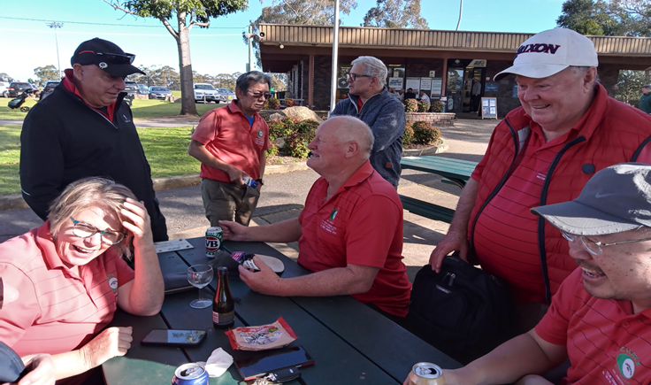

**WEDNESDAY WARRIORS**

**We are thinking of re-naming this group The Diehards. What was previously a reasonably well attended regular Wed morning outing has now reduced to just 3 diehard early morning risers. We have occasional visitors but nowadays mostly it’s just the same three stalwarts. ☹**

**This year we have been severely affected by the terrible weather, so much so that we have played only 14 games. Neil Vidler has been consistent, racking up a few wins to lead the pointscore tally at the half way mark. But there is a long way to go – if the weather is kinder.**

*Opinions expressed in this newsletter are those of the Editor and not necessarily those of the Chatz Social Golf Club*

**CHATZ SOCIAL GOLF CLUB INCORPORATED**

*Affiliated sporting club of Chatswood RSL*